**Part B**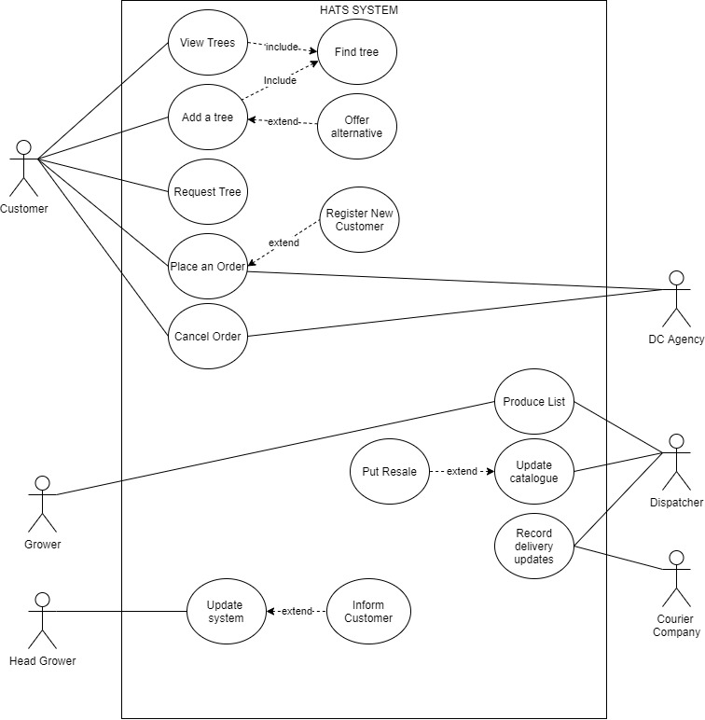

**Part C**

**Use Case**: **Add Tree**

**Actors**: Customer

**Goal**: To add tree to an order

**Precondition**: Customer has searched for desired tree from HATS catalogue

**Summary**: Customer adds tree to Order

**Related use cases**: Search Catalogue, Request Tree

**Steps** - **main flow**:

|  |  |
| --- | --- |
| **Actor action:** | **System Response:** |
| 1.Customer inputs search criteria for tree |  |
|  | 2. System searches catalogue for matches |
|  | 3. System returns matches |
| 4.Customer adds tree to order |  |
|  | 5. System returns to step 1 |

**Steps** - **exceptional flow**.

|  |  |
| --- | --- |
| **Actor action:** | **System Response:** |
| Exceptional flow 1: |  |
|  | 2. [Match not found]  offer alternatives |
| Exceptional flow 2: |  |
|  | 3.[Alternative tree not selected] Request Tree |
| Exceptional flow 3: |  |
|  | 5. [Desired trees selected]  Exit use case |

**Use Case**: **Place Order**

**Actors**: Customer, Debit Card Agency

**Goal**: To place an Order for Trees

**Precondition**: Customer has selected list of trees to purchase

**Summary**: Customer confirms order for selected trees.

**Related use cases**: Register New Customer

**Steps** - **main flow**:

|  |  |
| --- | --- |
| **Actor action:** | **System Response:** |
| 1. Customer confirms order |  |
|  | 2. System checks if the customer has account with HATS |
| 3. Customer enters debit card details |  |
|  | 4. System directs customer to Debit card agency |
| 5. Debit card agency validates payment |  |
|  | 6. Records the order and process order details. |
| 7. Customer receives order details |  |

**Steps** - **exceptional flow**.

|  |  |
| --- | --- |
| **Actor action:** | **System Response:** |
| Exceptional flow 1: |  |
|  | 2: [Customer does not have account] Register New Customer, Moves to step 3 |
| Exceptional flow 2: |  |
|  | 5:[Payment failed]  Return to step 3 |
| Exceptional flow3: |  |
| (any step before 5)  Customer cancel order | Exit use case |

**Part D**

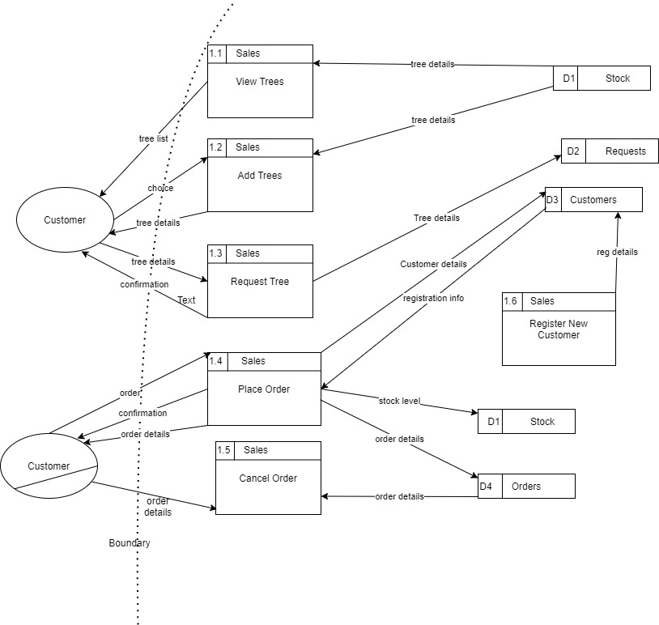

**Part E**